**Project Design Phase-II**

**Customer journey**

|  |  |
| --- | --- |
| Date | 03October 2022 |
| Team ID | PNT2022TMID30411 |
| Project Name | IOT based safety gadget for child safety monitoring and notification |
| Maximum Marks | 4 Marks |

**What is Customer Journey Child safety Monitoring?**

**\* Customer Journey Monitoring is about understanding how a customer that interacts with your organisation through any channel (Website, Mobile App, Call Centre, IVR etc.) and what systems they touch in order to complete a journey.**

**\* A journey can be anything; Placing an order for a new smartphone, making a complaint, making a payment, booking a vacation are common examples you might think of.**

**\* But a customer journey can also involve interactions that are invisible to the customer themselves — perhaps you run the network that the Customers smartphone runs on — the act of the customer placing a call or browsing a website is a journey that you would need to be aware of. Perhaps you run the utility company that provides Electricity, Gas or Water.**

**\* These journeys are just as important to the Customer and happen “in the background” and only become important to the Customer when something goes wrong. It’s at that point that the complaints are made, or calls to the call centre happen, and more often than not — it’s only at that point when an Organisation realises that there’s a problem — when customers start complaining.**

**You monitor your kids’ behavior, why wouldn’t you monitor your customers’?**



**Customer journey analytics is one of the keys to unlocking insights based on your customers’ actions. O3 partners with our clients to drive better customer experiences and increase ROI. We firmly believe that tracking your consumers’ activity (how they navigate your site, how much time they spend on a page, things they click on, and where they decide to leave from) throughout their online interactions (across touchpoints and multiple visits) with your brand can help you better serve them in many ways.**

**Real-time behavioral data collection and response allows for specific, timely and relevant messaging, positively impacting their decision making while also helping you predict future behavior and driving sales. Three key influential elements of this approach are:**

**\* Cognitive – knowing, understanding and then delivering on your consumers’ expectations and beliefs drives relatability**

**\* Personal – the specific details of who they are and what they believe helps drive buying decisions**

**\* Social – shared experiences develop emotional connections and bonds, which guide loyalty and lifetime value**

**The Customer Journey Management Framework**

**\*** 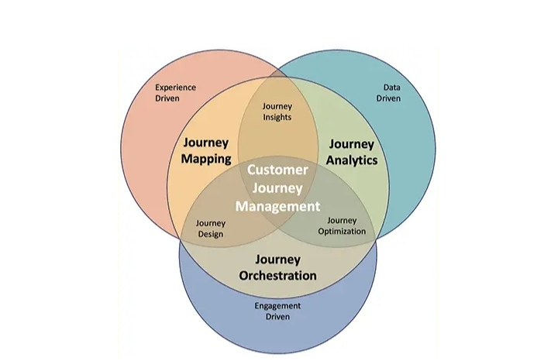

Customer Journey Management:

Comprehensive Guide:

Customer journey management is a proven approach to delivering the seamless experiences your customers demand. Today, customers expect that their experience with your business will mimic those of CX leaders like Amazon, Google and Netflix. Anything less can lead to dissatisfaction and a likelihood of churn.

Although many organisations have already adopted customer feedback management, 73% of companies failed to improve their CX scores last year despite this investment. The reason is simple: Voice of the Customer (VoC) data is only measured in aggregate, by segment, or after isolated transactions within individual touchpoints. It doesn’t enable you to understand and optimise individual customer experiences or measure their impact on business outcomes. And only a fraction of your customers are responding to your surveys.

In this blog, I’ll share how you can use customer journey management to achieve your CX and business goals by organising your business around customer journeys. Then I’ll walk through seven high-impact journeys every business should measure and optimise.

What is Customer Journey Management?

Customer journey management focuses on the journeys your customers take as they seek to achieve a goal, rather than optimising single interactions at each touchpoint. It’s a shift in mindset that enables you to not only measure, monitor and optimise CX, but align your entire organisation with your customers’ goals.

Customer journey management is used by customer-centric organisations to:

Identify the journeys that matter based on customer goals and business outcomes

Measure and monitor the in-journey signals that predict journey success

Orchestrate corrective actions when needed

Track journey success using journey success scores, and

Prioritise underperforming journeys for investment

Leading enterprises around the world are using customer journey management to improve customer experience, delivering value to both their customers and their organisation.

The Value of a Journey Management Approach

The primary motivation behind the adoption of customer journey management is to improve your organisation’s ability to deliver value to your customers. It is the method by which customer-centric enterprises understand customer goals and help them reach those goals as efficiently as possible. Powered by this approach, you can ensure that each interaction reflects each customer’s unique journey context.

Satisfied customers will return value to your business. The key is to identify the experiences critical to obtaining that value and quantify their impact on business outcomes.

Yet, many enterprises struggle to directly link customer behaviour to business outcomes. According to the latest State of Customer Journey Management and CX Measurement report, almost half (41%) of companies say that they capture improvements in metrics like Net Promoter Score (NPS) or customer satisfaction, but they are challenged to translate that into revenue or costs.

Managing customer journeys provides you with the framework to deliver the experiences customers expect and influence the metrics and outcomes that matter most. A journey management program benefits your enterprise in four major ways:

1. Optimise Customer Experience

Customer journey management enables you to provide customers with exceptional, consistent experiences no matter what goal they want to achieve and which channels they use throughout their journey.

CX leaders use customer journey management to measure, monitor and optimise their customers’ experiences. By continuously monitoring journey performance, you can identify which journeys or moments within a journey need improvement, as well as prioritise each improvement by its potential impact on journey scores and other CX KPIs.

steps in the customer journey management framework

Journey management is a closed-loop approach, which helps journey owners determine how each action taken to optimise journeys affects CX metrics. Customer journey management software allows you to customise journey dashboards and monitor your progress in real time. This way, you can see if your improvements are yielding the desired results and iterate your tactics as customers engage with your organisation.

2. Accelerate Digital Transformation

To meet evolving customer expectations and compete in today’s rapidly changing landscape, companies are focused on transforming outdated experiences and the underlying processes and systems that support them. Chief Digital Officers can use customer journey management to provide the simple digital experiences their customers crave, while minimising costly and often frustrating human interactions.

Product owners can use journey management to answer complex questions like:

Are customers achieving their goals using digital products?

Which channels are the most effective for specific types of journeys?

At what point are customers leaking from digital channels into the contact centre?

For which products do customers abandon digital options to speak with an agent?

3. Improve Customer Service While Reducing Costs

Transforming internal operations and decreasing costs associated with servicing customers is a top priority for every organisation. Inevitably, some customers will leak from digital channels — or bypass them altogether — into agent-supported channels like chat and phone. Contact centre leaders must understand why customers seek agent assistance and what goals they’re trying to achieve.

When supported by a customer journey management program, agents can see everything a customer has done outside of the contact centre, as well as the journey or journeys they’re currently taking. This enables them to support customers more effectively and efficiently, reducing call centre metrics like call time and repeat calls.

Monitoring journeys over time and across channels allows customer service leaders to improve escalation management by isolating the cause of severe cases, determining how many other customers are experiencing the same issue and avoiding or mitigating those issues more efficiently to reduce costs.

4. Grow Revenue

Today, enterprises are more likely to win consumers’ hearts with experiences rather than products and services. Marketing leaders know it’s important to deliver differentiated experiences as prospective clients or customers shop and buy, but most are challenged to do so. If your organisation is managing customer journeys, you have the capabilities to track acquisition journeys across channels and ensure that each interaction reflects the unique experiences each consumer has with your business.

Similarly, marketing teams can use a journey management approach to expand revenue from existing customers by sending cross-sell or upsell offers. Monitoring customer journeys and incorporating journey context allows marketers to orchestrate these offers at the right moment for each customer and through the best channel.

Lastly, customer journey management makes it easy to monitor journeys and reveal the indicators of voluntary and involuntary churn. CX and marketing professionals can increase retention by understanding which journeys lead to churn, examining the root causes of CX issues and prioritising actions to optimise those journeys.

The Customer Journey Management Framework

customer journey management framework

Customer journey management encompasses three primary approaches to CX: journey mapping, journey analytics and customer journey orchestration.

Each approach plays a role in helping an organisation understand, create and improve customer experiences. In addition, these approaches are often combined to enhance experience design, generate journey insights and optimise journeys.

Here is a quick summary of the three primary journey management capabilities and the three most frequently used ways to combine them.

* Journey mapping: Is a way to visualise and communicate your customer’s experience across touchpoints and over time as they seek to achieve a specific goal.

* Journey analytics: Is the science of analysing customer behaviour data across touchpoints and over time to measure the impact of customer behaviour on business outcomes.

* Journey orchestration: Is a way to use each customer’s entire experience to inform and personalise interactions that will improve customer experience and drive desirable outcomes.

* Journey insights: Are the quantitative and qualitative information that help you understand the behaviour of your customers as they seek to achieve a goal.

* Journey design: Is the process of defining the experience a customer has as they seek to achieve a goal and the interactions the company will take at each step to promote progress towards the goal.

* Journey optimisation: Is a closed loop approach that uses AI and machine learning to improve the experience of each customer, so they can achieve their goal more efficiently.

Child safety monitoring and notification to customer journey map:

